AZURE STORAGE ACCOUNTS:
The Azure Storage platform is Microsoft's cloud storage solution for modern data storage scenarios. Core storage services offer a massively scalable object store for data objects, disk storage for Azure virtual machines (VMs), a file system service for the cloud, a messaging store for reliable messaging, and a NoSQL store. The services are:
- Durable and highly available. Redundancy ensures that your data is safe in the event of transient hardware failures. You can also opt to replicate data across datacenters or geographical regions for additional protection from local catastrophe or natural disaster. Data replicated in this way remains highly available in the event of an unexpected outage.
- Secure. All data written to an Azure storage account is encrypted by the service. Azure Storage provides you with fine-grained control over who has access to your data.
- Scalable. Azure Storage is designed to be massively scalable to meet the data storage and performance needs of today's applications.
- Managed. Azure handles hardware maintenance, updates, and critical issues for you.
- Accessible. Data in Azure Storage is accessible from anywhere in the world over HTTP or HTTPS. Microsoft provides client libraries for Azure Storage in a variety of languages, including .NET, Java, Node.js, Python, PHP, Ruby, Go, and others, as well as a mature REST API. Azure Storage supports scripting in Azure PowerShell or Azure CLI. And the Azure portal and Azure Storage Explorer offer easy visual solutions for working with your data.

The Azure Storage platform includes the following data services:
- Azure Blobs: A massively scalable object store for text and binary data. Also includes support for big data analytics through Data Lake Storage Gen2.
- Azure Files: Managed file shares for cloud or on-premises deployments.
- Azure Queues: A messaging store for reliable messaging between application components.
- Azure Tables: A NoSQL store for schemaless storage of structured data.
- Azure Disks: Block-level storage volumes for Azure VMs.
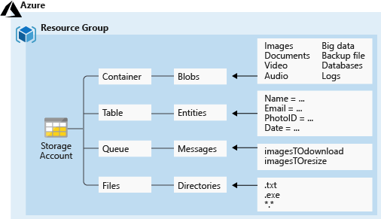

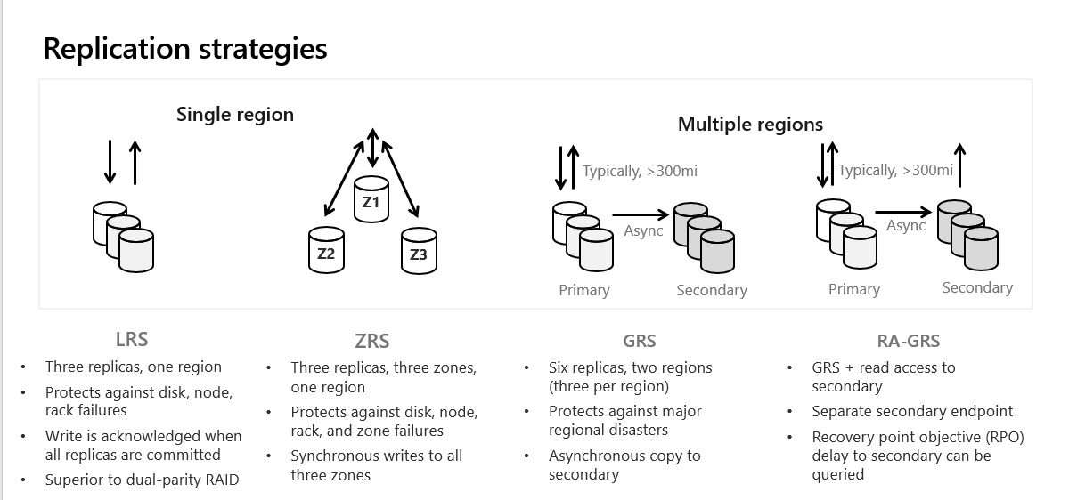

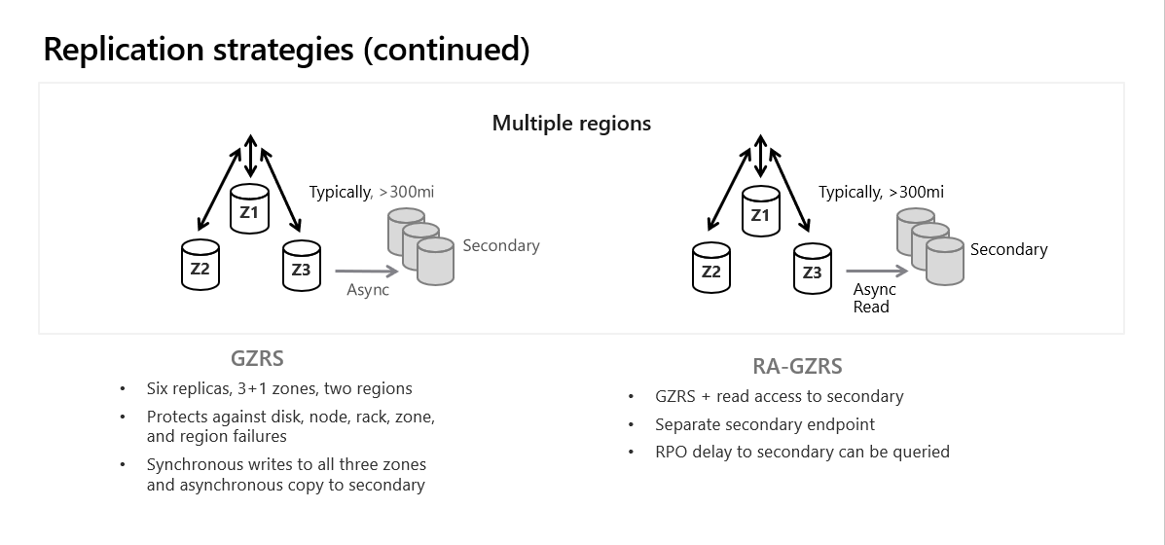

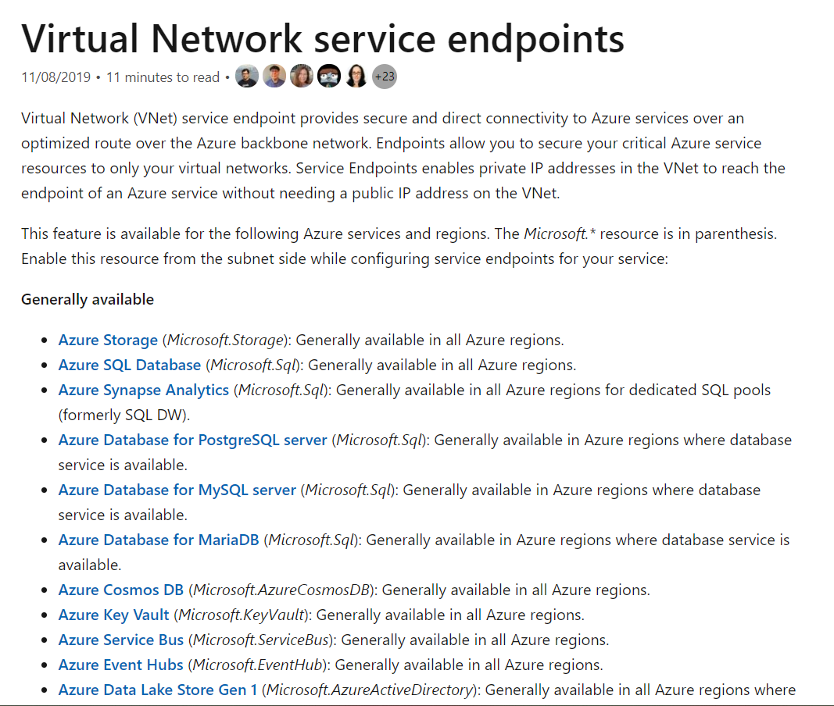

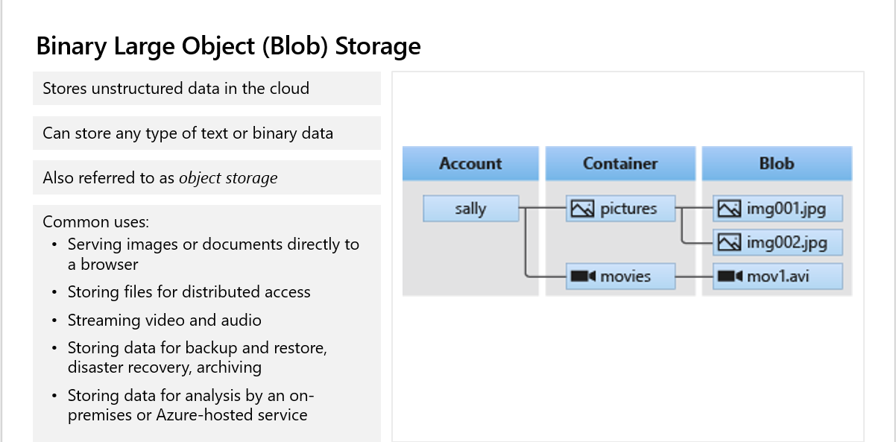

Azure Blob Storage | Microsoft Azure

SHARED ACCESS SIGNATURE:

Grant limited access to data with shared access signatures (SAS) - Azure Storage | Microsoft Docs

AZURE FILE SHARE:

Create and use an Azure file shares on Windows VMs | Microsoft Docs
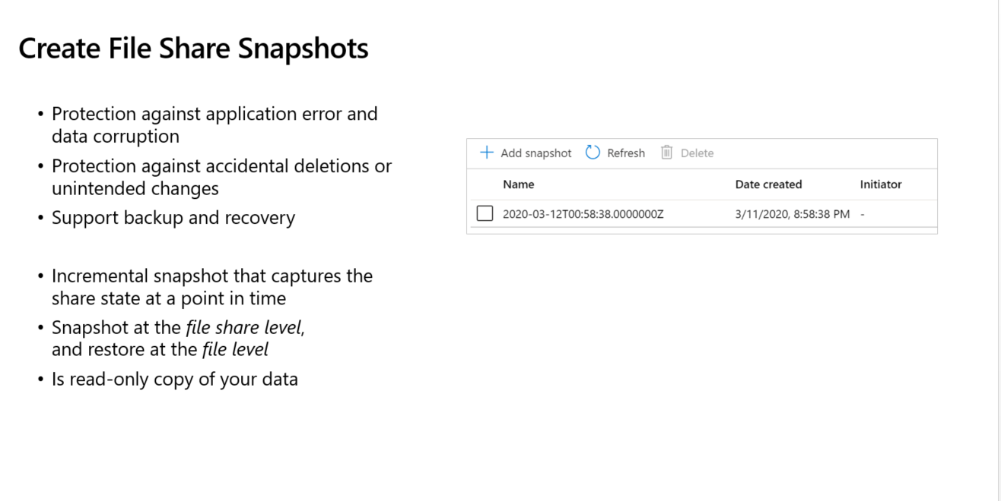

AZURE FILE SYNC:
Azure File Sync | Azure updates | Microsoft Azure

